

**MIDDLE EAST TECHNICAL UNIVERSITY**

**DEPARTMENT OF ELECTRICAL & ELECTRONICS ENGINEERING**

**EE 464- Hardware Project – 2023 Spring**

**Final Report**

**Isolated DC-DC Battery Charger**

**Peaky Converters**

Çağlar Umut Özten

Onur Toprak

Table of Contents

Introduction 3

Key Project Requirements: 3

Additional Objectives: 3

Challenges and Opportunities: 3

Topology Selection 4

Flyback Converter: 4

Forward Converter: 5

• Two Switch Forward Converter 5

TOPOLOGY OPERATION 7

MOSFET ON CASE 7

MOSFET OFF CASE 8

Analytical Calculations 10

Magnetic Design 10

• Magnetizing and Leakage Inductance Tests 13

Component Selection 15

• MOSFET 15

o GATE DRİVER 16

• DİODE 16

• OPTOCOUPLER 17

Closed Loop Controller 17

Overview: 18

Key Features: 18

Functional Blocks: 18

Typical Applications: 19

Controller Tuning 19

1. Oscillator Tuning: 19

2. Error Amplifier Tuning: 19

3. Current Sense Comparator Tuning: 20

4. PWM Comparator Tuning: 20

5. Under-Voltage Lockout (UVLO) Tuning: 20

6. Output Driver Tuning: 20

General Tuning Tips: 21

Simulations 21

Loss Calculations 23

Implementation Process 24

Cost Analysis 25

Bonuses 25

Conclusion 27

Achievements 27

Appendix-I : TEST DATA 28

References 34

# Introduction

Due to a variety of applications, including portable electronics and renewable energy systems, there is a constant need in modern power electronics for DC-DC converters that are dependable and efficient. The goal of this project is to design and build an isolated DC-DC converter that satisfies tight requirements for power efficiency, output voltage stability, and input voltage range.   
  
 This converter's goal is to convert an input voltage between 20 and 40 volts into a steady 12 volt output with a maximum power output of 60 watts. Additionally, the converter must have outstanding line and load regulation, with variances of no more than 3% across a range of input voltages and load circumstances, and the output voltage ripple should be kept to a maximum of 3%.

## Key Project Requirements:

**Closed-Loop Control:** A closed-loop control system is essential for maintaining precise regulation of the output voltage under changing input and load conditions. This ensures stability and reliability in various operating scenarios.

**Self-Powered Control Circuits:** The project restricts the use of external power supplies for control circuits, emphasizing the need for a self-powered solution that derives its operational energy from the main power source.

**Magnetic Design:** The magnetic design for the isolated DC-DC converter is a critical aspect that directly impacts performance, efficiency, and size of the converter. The key components requiring careful magnetic design include transformers and inductors.

## Additional Objectives:

Beyond meeting the basic specifications, additional project goals may involve enhancing the converter's efficiency, achieving a compact design, and exploring advanced techniques like soft switching to minimize switching losses and improve overall performance.

## Challenges and Opportunities:

Designing an efficient isolated DC-DC converter requires addressing challenges related to component selection, circuit layout, magnetic design (transformers and inductors), and control strategy. Balancing performance with factors like cost, size, and complexity presents opportunities for innovation and optimization throughout the design process.

Throughout this report, procedure of the DC-DC Isolated Converter will be explained. Step by step, examination of the topology selection, magnetic design and controller will be carried. After checking results with simulations, component selection and further consideratioons will be done.

# Topology Selection

## Flyback Converter:

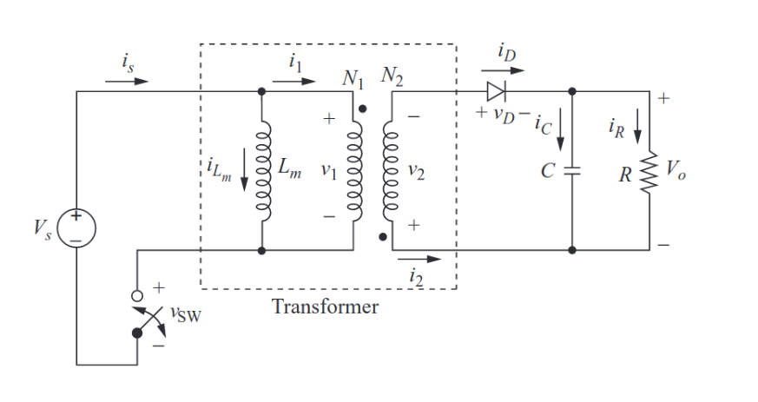

The flyback converter is a type of isolated DC-DC converter that stores energy in the transformer during the ON time of the switching cycle and releases it to the output during the OFF time. Here's a simplified explanation of how it works:

**Operation:** During the ON time of the switching cycle, the primary winding of the transformer is energized, storing energy in the magnetic field of the transformer core.

**Energy Transfer:** When the switch turns OFF, the magnetic field collapses, inducing a voltage in the secondary winding of the transformer. This voltage is rectified and filtered to provide the desired output voltage.

**Isolation:** The flyback converter provides galvanic isolation between the input and output through the transformer, making it suitable for applications requiring isolation such as in power supplies and converters.

**Advantages:** Simple topology, low component count, and capability of stepping up or stepping down the input voltage.

**Disadvantages:** Typically higher output ripple, lower efficiency compared to forward converters especially at higher power levels, and limited to lower power applications due to transformer size and losses.

## Forward Converter:

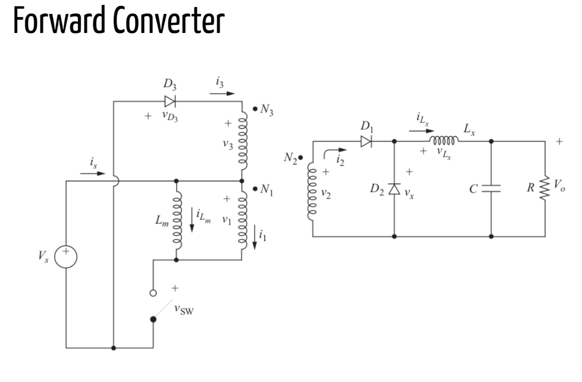

The forward converter is another type of isolated DC-DC converter that transfers energy from the input to the output through a transformer during each switching cycle. Here's a brief overview of its operation:

**Operation:** The primary winding of the transformer is energized during the ON time of the switching cycle, transferring energy to the secondary winding.

**Energy Transfer:** Energy is transferred from the primary side to the secondary side of the transformer during each switching cycle, providing isolation and stepping up or stepping down the voltage depending on the transformer turns ratio.

**Continuous Energy Transfer:** Unlike the flyback converter, the forward converter operates with continuous energy transfer through the transformer, resulting in generally higher efficiency and lower output ripple.

**Advantages:** Higher efficiency, lower output ripple, and better regulation compared to flyback converters especially at higher power levels.

**Disadvantages:** More complex control circuitry, additional components such as freewheeling diodes and snubber circuits, and limited duty cycle due to transformer reset constraints.

## Two Switch Forward Converter

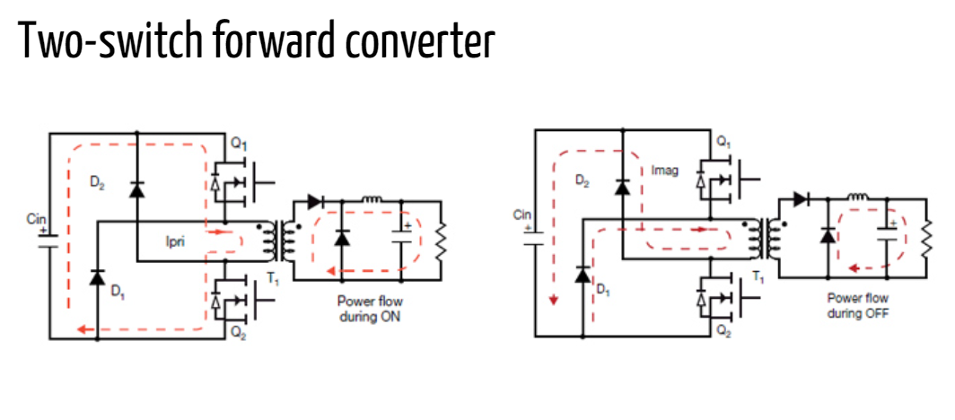

The Two-Switch Forward Converter utilizes two active switches (typically MOSFETs) in its primary side circuitry, enhancing its performance and efficiency over the conventional single-switch forward converter. This topology is commonly employed in high-power applications where minimizing losses and improving efficiency are paramount.

**Key Components and Operation:**

Transformer: Similar to the single-switch forward converter, the Two-Switch Forward Converter includes a transformer that facilitates the energy transfer from the input to the output. The transformer typically features separate primary and secondary windings for isolation.

Primary Side:

Active Switches (MOSFETs): The primary side of the converter incorporates two active switches (MOSFETs) configured in a half-bridge topology. One switch is responsible for controlling the primary current during the ON state, while the other switch helps to clamp the leakage energy during the OFF state.

Input Capacitor: A capacitor is connected to the input to filter the input voltage and provide a smooth supply to the switches.

Secondary Side:

Diode and Output Capacitor: The secondary side includes a diode for rectifying the transformer's secondary voltage and an output capacitor to filter the rectified voltage, providing a stable output voltage to the load.

In summary, the choice between flyback and forward converter topologies depends on specific application requirements including power level, efficiency targets, output ripple tolerance, and design complexity considerations. Each topology has its advantages and disadvantages, making them suitable for different types of DC-DC conversion applications.

To conclude, **the Forward Converter** offers enhanced performance and efficiency making it a compelling choice for demanding power conversion applications where minimizing losses and optimizing efficiency are key priorities. Advanced control techniques and careful design considerations are essential for realizing the full potential of this topology in practical implementations. We will try to implement and design for Forward Converter.

## TOPOLOGY OPERATION

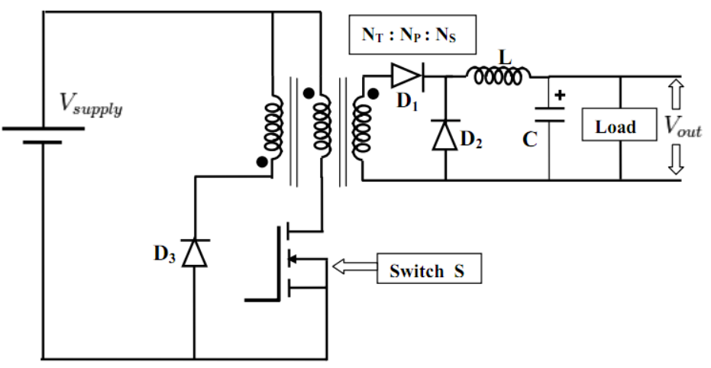

Figure 1. Selected Topology

Firstly, we will explain selected topology. Forward converter works with 2 operation mode. These modes are listed below:

### MOSFET ON CASE

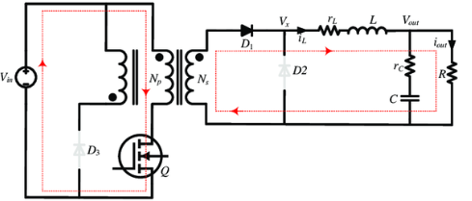

Figure 2. MOSFET ON Case

During this phase of operation, the MOSFET switch is turned on, allowing current to flow from the input source directly through the primary winding of the transformer. At this moment, diodes 3 and 2 are reverse biased, preventing current flow in those paths, while diode 1 is forward biased, facilitating the flow of current from the input source and the primary winding.

As current flows through the primary winding, energy is stored in the transformer's magnetic field. Then this energy is transferred to secondary side with secondary winding. The primary current builds up gradually, controlled by the input voltage, the transformer's inductance, and the duty cycle of the switching signal. Meanwhile, on the secondary side of the circuit, the inductor and capacitor are charging.

The duration of this phase is determined by the duty cycle of the converter. The duty cycle represents the fraction of time the MOSFET switch remains on during each switching period. During this on-time, energy is transferred from the input source to the transformer's primary winding, initiating the energy conversion process.

In summary, when the MOSFET is on in a forward converter, current flows from the input source through the primary winding, storing energy in the transformer's magnetic field. Simultaneously, on the secondary side, the load is supplied with power as the secondary winding induces a voltage, charging the output capacitor and providing the necessary current. This phase of operation sets the stage for the subsequent phases in the converter's switching cycle.

### MOSFET OFF CASE

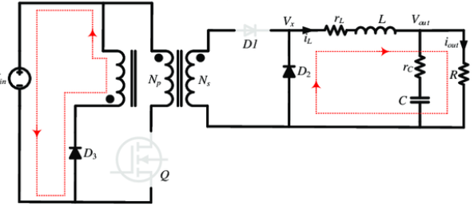

Figure 3. MOSFET OFF Case

When the MOSFET is turned off in a forward converter with a third winding, the operation enters a critical phase for energy transfer.

MOSFET Turn-off: At the end of the on-time, the MOSFET switch is turned off. This action interrupts the current flow through the primary winding. As a result, stored magnetic energy at the magnetizing inductance disappear on third winding and diode. When this operation occurs, required current is supplied from inductor at secondary side. So, inductor is discharging at this operation mode.

Diode Action: With the MOSFET off, diodes 3 and 2 become forward biased, while diode 1 becomes reverse biased. The voltage induced across the third winding is of opposite polarity to that of the primary and secondary windings. This causes diode 3 to conduct, providing a path for the third winding's energy to circulate back to the input source.

Resetting the Transformer: The collapsing magnetic field causes the transformer's core to reset, preparing it for the next switching cycle. This resetting process is crucial for ensuring efficient energy transfer and preventing transformer saturation.

Control of Duty Cycle: The off-time of the MOSFET, along with the on-time, determines the duty cycle of the converter. Adjusting the duty cycle allows for control over the output voltage and current regulation.

In summary, during the off time of the MOSFET in a forward converter with a third winding, energy transfer continues as the transformer's magnetic field collapses. Diode 3 conducts, providing a path for the energy stored in the magnetizing inductance. This phase of operation ensures efficient energy transfer and proper functioning of the converter.

Operation Waveforms can be seen in Figure 4.

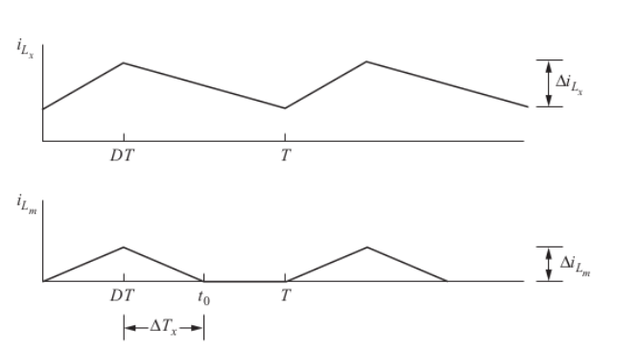

Figure 4. Operation Waveforms

From the resulted waveforms, we can easily say that gain of this converter is calculated as

$$Vl = L * dI / dT$$

$$Vin * N2 / N1 – Vout = L* dI / dT (1)$$

$$-Vout = L * dI / dT (2)$$

From these equations, as we know, current changing on inductor should be same at these two operation mode. So, charging period is D * Ts and discharging time is (1 – D) * Ts. From these equations we can derivate the output gain like this

$$Vout / Vin = D * N2 / N1$$

Moreover, we should consider duty cycle value. As we discussed, energy on magnetizing inductance should be reset. So, maximum duty cycle should be considered. In this design, we will design our transformer according to this turn ratios:

$$N3 / N1 = 1$$

So, for resetting the third winding maximum duty cycle for this converter type should be 0.5. When switch is on, magnetizing inductance charges on the on period, which is D * Ts and at the off period magnetizing inductance is discharging. This period is (1 – D) * Ts. As we discussed above, stored energy on the magnetizing inductance can be determined from inductor current equation. From the equations, we can easily say that maximum duty cycle for the safety operation occurs at 1 – D = D, so maximum duty cycle is calculated as 0.5. These calculations will be discussed more detailed next chapters.

# Analytical Calculations



At the beginning, for the not saturated core and high core losses, duty cycle must be smaller than 0.5. Moreover, due to the non-idealities and some deviations, the most duty cycle value is taken as 0.45. After that, from the equation, 𝑉𝑜𝑢𝑡 = 𝑉𝑖𝑛 ∗ (𝑁2/𝑁1) ∗ 𝐷, required turns ratio at the 20 V input case is 1.33. After that, for simplicity and safety of the operation modes, turns ratio determined as 1.5. Then duty cycle is calculated for 40 V input voltage case. Value is calculated as 0.3. Finally, with the turn ratio is 1.5, required duty cycle at 20 V input voltage case calculated as the 0.4.

In conclusion, turns ratio determined as the 1.5 and duty cycle varies between 0.2 and 0.4.

# Magnetic Design

By following Infenion’s Forward Design Handout[(1)](https://www.mouser.com/pdfdocs/2-10.pdf);

$n_{1}> \frac{V_{i},\max{ * } Dmax * 1/{f_{S}}}{B_{sat} * { A}_{e}}$**(1)**

$$k_{fill}= \frac{Total copper Area}{Window Area} (2)$$

$L_{o}>(1-\frac{ V_{o} * n1}{V_{i} * n_{2}})* \frac{1}{∆i_{Lo}}$ $* V_{o}*\frac{1}{f_{s}} =96 µH$**(3)**

$ƞ =\frac{P_{o}}{P_{i}}$, ( 80%) $I_{pri,mean,on}=$ $\frac{P_{i}}{V_{i }D}$ = **9.375 A** **(4)**

$∆i_{Lo}=\frac{\left(\frac{n_{2}}{n_{1}} V_{i} - V_{o}\right)t_{on}}{L_{o}}=0.66 A_{pp}$**(5)**

$∆i_{pri}=\frac{∆i_{Lo}}{{2 . I}_{lo,max}}.I_{pri,mean,on}=0.61875 A_{pp}$**(6)**

$∆i_{Lm}=\frac{V_{i} . t_{on}}{L_{m}}$**(7)**

+ **(8)**

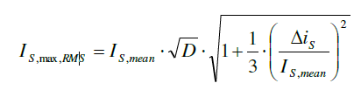 **(9)**

* Consideration of Toroidal Core;

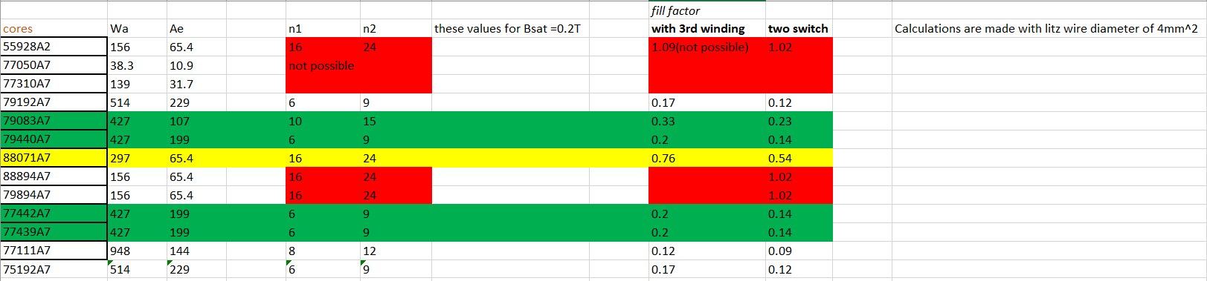

Figure 5. Table for Toroidal core turns and fill factor Calculations using (1) and (2)

By looking at this table (Figure 5), we decided to use 79440A7 core. After implementation of the 6:9 turns ratio on the core by Litz wire, we started to calculate $L_{magnetizing}$ (Magnetizing Inductance) and $L_{leakage}$ (Leakage Inductance). After testing on LCR Meter, we understood that, its $L_{leakage}$ is too high and $L_{magnetizing}$ is too low if we consider current ripple on the MOSFET **(7)**. So that, we decided to use **E-core**.

After consideration of the E-cores in labaratory, we decided to use **0P45530EC cores.**

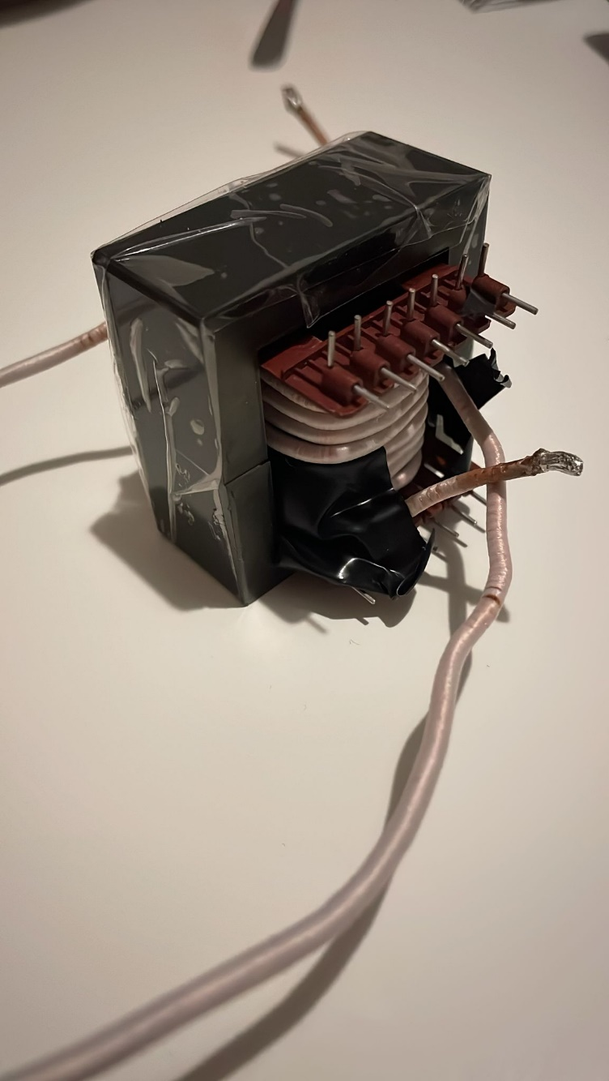

Figure 6. Transformer Design with **0P45530EC and 4:4:6, Litz wire**

For output inductor, consideration of ensuring CCM at 10% load; $∆i_{Lo}<1 A$

We calculated minimum output inductance as **96 µH**, by using (3).

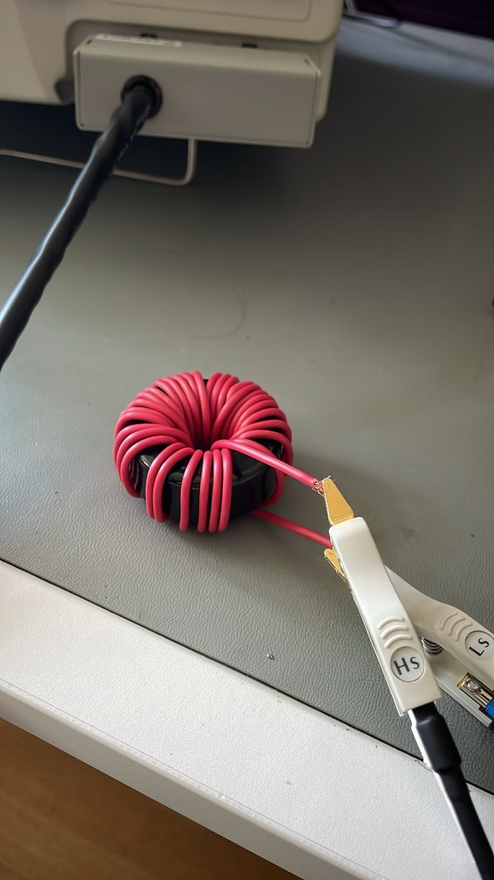

Figure 7. Output inductor design and test setup

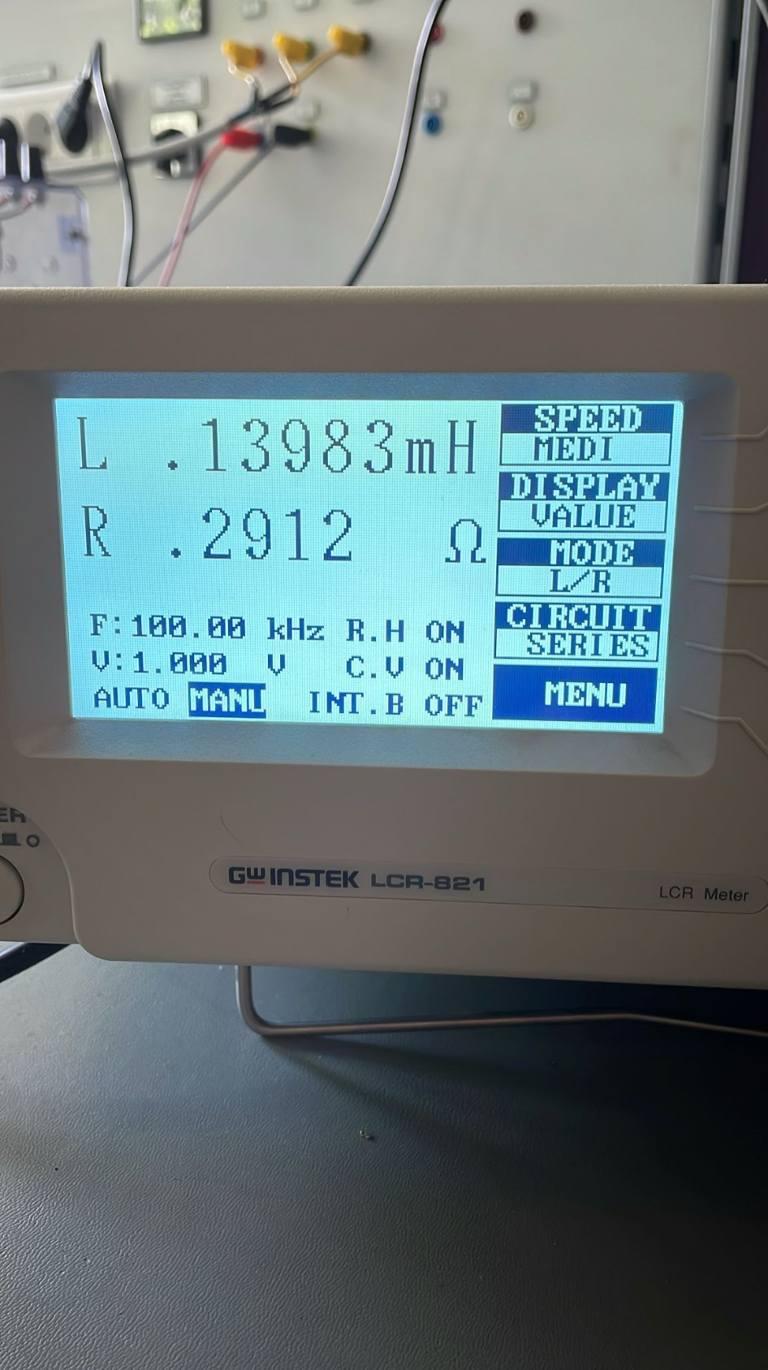

Figure 8. RL Test for Output Inductance

## Magnetizing and Leakage Inductance Tests

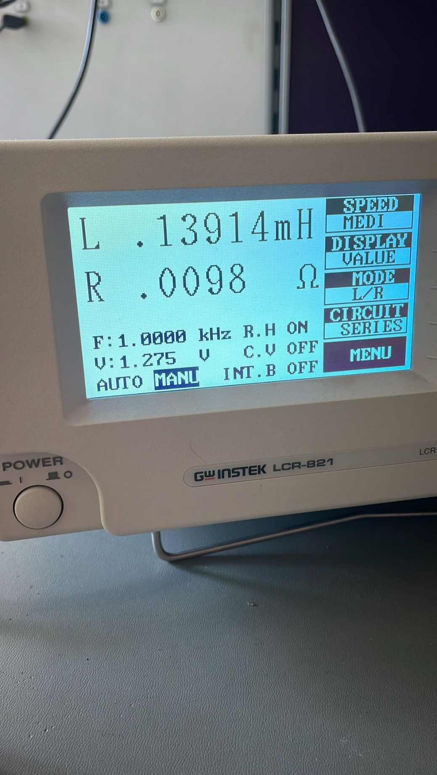

Figure 9. From Primary side, Secondary open

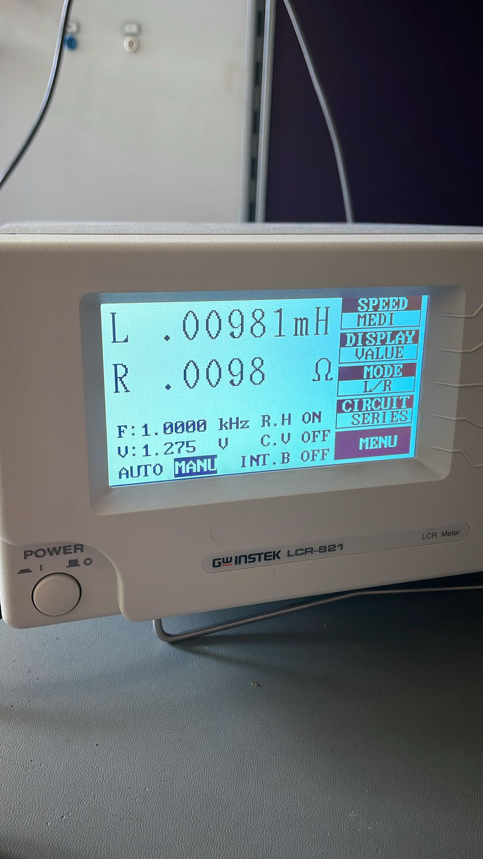

Figure 10. From Primary side, Secondary shorted

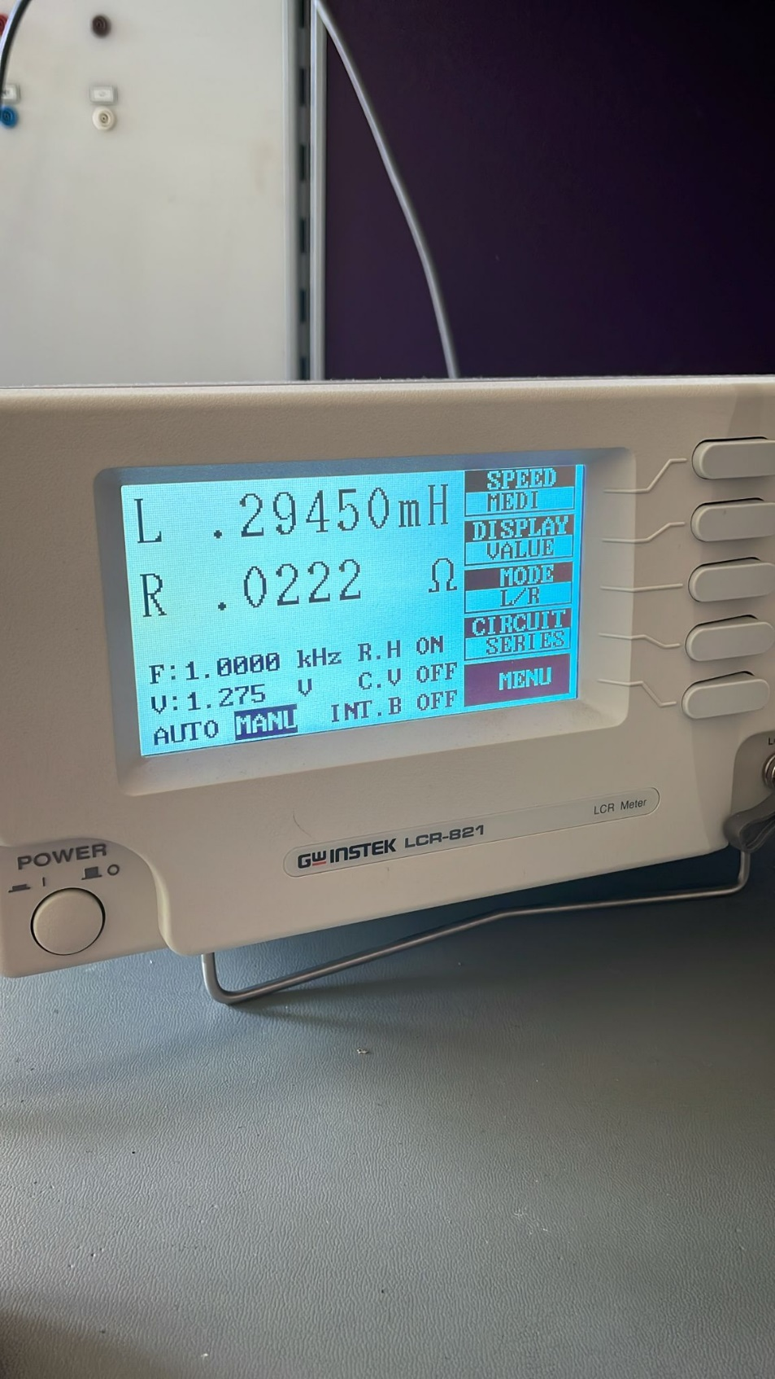

Figure 11. From Primary side, Secondary open

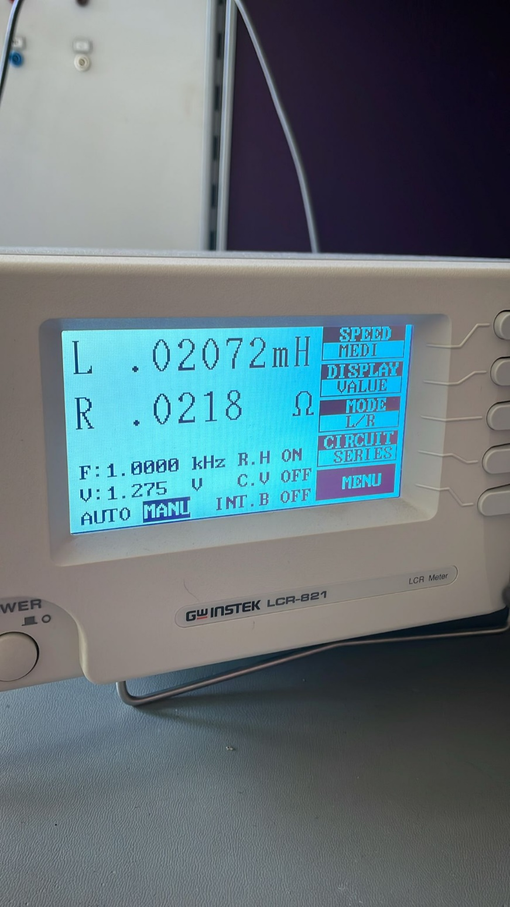

Figure 12. From secondary, primary shorted

From these tests we concluded that:

$L_{l1}=9.8$**µH**

$L_{M}=130$**µH**

$L_{l2}=20.7$**µH**

# Component Selection

## MOSFET

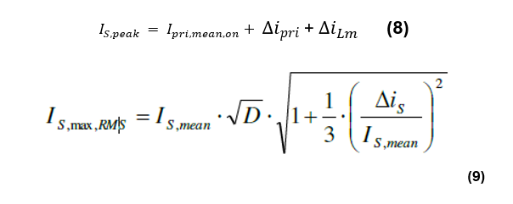

Consideration of these equations for MOSFET, we decided to use IRF640N. Its mean and peak values are below rated for this MOSFET.



Figure 13. IRF640 MOSFET

$$P_{s,conduction}=I_{rms}^{2} . R_{ds,on}=2.5 W$$

$$P_{s,switching}=V_{in} . I_{out}. f_{sw} . \frac{(Q_{gs}+Q_{gd})}{I_{g}}=2W$$

### GATE DRİVER

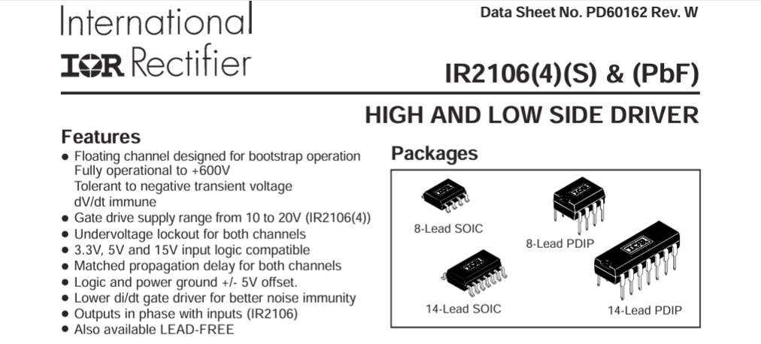

Figure 14. IR2106 Driver

IR2106 driver for forward converter used to drive our mosfets.

## DİODE

Selection of 10A ratings will be enough for this application.

**MBR2010CT** diodes can be selected for this application.



Figure 15. MBR20100CT Diode

$$I_{D1,max,rms}=\frac{V_{i }. }{L_{m} . D_{max}}. √\frac{f_{s}}{3}=1.2 A$$

$$P_{s,conduction}=I_{D1,max,rms} . V_{f}=1 W (per diode)$$

## OPTOCOUPLER

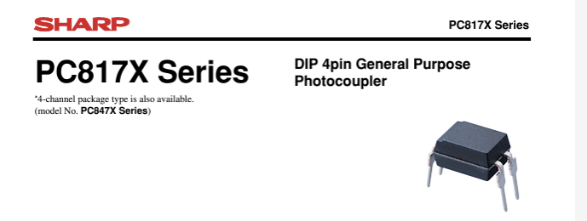

Figure 16. PC817 Driver

This PC817 Optocoupler is used to have an isolated feedback for our design. We used current ratings for this optocoupler by having a voltage reference by looking at the datasheet of this tp make sure it can stand and correctly send information on this current.

# Closed Loop Controller

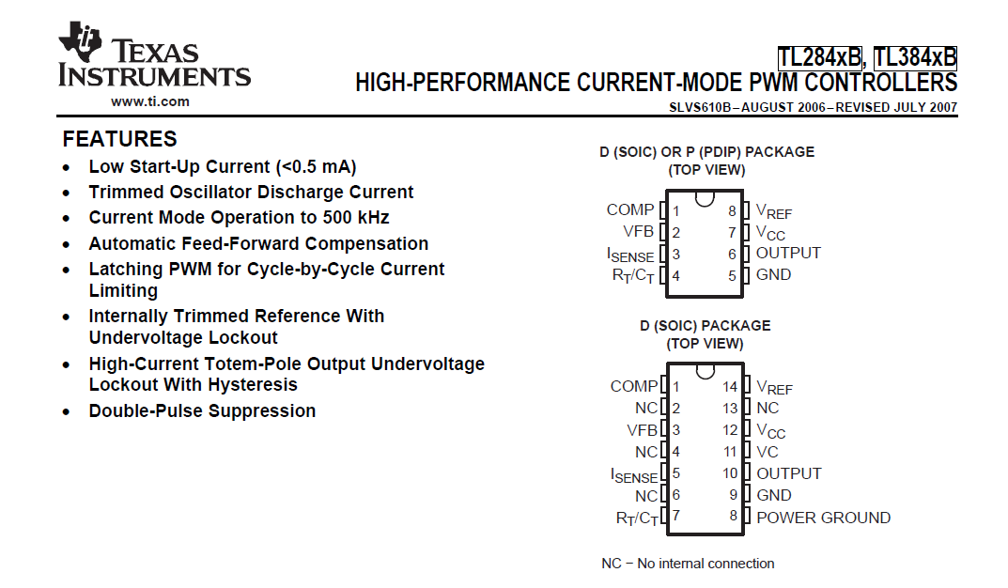

Figure 17. UC3843 Controller

### Overview:

* **Type**: PWM controller
* **Applications**: Forward converters, boost converters, flyback converters, and other DC-DC converters
* **Package Types**: Available in various packages including DIP, SOIC

### Key Features:

1. **High Performance**:
   * **Fixed-Frequency Operation**: Typically operates at a fixed frequency set by an external resistor and capacitor.
   * **High Gain Amplifier**: Incorporates a high gain error amplifier for precise voltage regulation.
2. **Efficient Control**:
   * **Current Mode Control**: Provides peak current mode control, which simplifies feedback loop compensation and provides excellent line regulation.
   * **Leading-Edge Blanking**: Prevents false triggering of the current sense comparator.
3. **Protection Features**:
   * **Under-Voltage Lockout (UVLO)**: Ensures the controller starts up only when the input voltage is sufficiently high.
   * **Over-Current Protection**: Limits the maximum current through the power switch to protect the converter from damage.
   * **Soft Start**: Limits inrush current during startup, reducing stress on power components.
4. **Output**:
   * **Totem-Pole Output**: Provides a high current to drive power MOSFETs directly.
   * **Push-Pull Drive Capability**: Enhances the switching performance of the power MOSFET.
5. **Operating Voltage**:
   * **Wide Supply Voltage Range**: Operates typically from 7V to 30V, accommodating various power supply designs.
6. **Frequency Range**:
   * **Adjustable Frequency**: Typically adjustable from 10kHz to 500kHz, allowing for flexibility in design and optimization of power efficiency.

### Functional Blocks:

* **Oscillator**: Sets the switching frequency through external timing components.
* **Error Amplifier**: Compares the feedback voltage to a reference and adjusts the PWM duty cycle to regulate output voltage.
* **PWM Comparator**: Compares the error amplifier output with the current sense signal to generate the PWM signal.
* **Current Sense Comparator**: Monitors the current through the power switch to prevent over-current conditions.
* **Output Driver**: Drives the gate of the power MOSFET with sufficient current for fast switching.

### Typical Applications:

* **Forward Converters**: Utilized in medium to high power applications requiring efficient power conversion and isolation.
* **Flyback Converters**: Common in low to medium power applications like AC-DC adapters and chargers.
* **Boost Converters**: Used in applications needing voltage step-up.
* **DC-DC Converters**: General-purpose DC-DC converters in industrial, automotive, and consumer electronics.

The UC3843 analog controller is a versatile and robust PWM controller well-suited for forward converter applications. Its combination of fixed-frequency operation, peak current mode control, and comprehensive protection features make it a reliable choice for efficient and precise power management in various converter designs.

## Controller Tuning

### 1. Oscillator Tuning:

* **Function**: Sets the switching frequency of the converter.
* **Components**: External resistor (Rt) and capacitor (Ct).
* **Tuning Steps**:
  1. **Select the Switching Frequency**: We determined the desired switching frequency based on the application requirements.
  2. **Calculate Rt and Ct**: We used the formula provided in the UC3843 datasheet to calculate the values of Rt and Ct for the desired frequency.

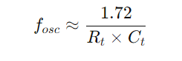

* 1. **Adjust for Stability**: We ensured that the chosen values provide stable operation without excessive jitter.

### 2. Error Amplifier Tuning:

* **Function**: Compares the feedback voltage to a reference and adjusts the PWM duty cycle to regulate the output voltage.
* **Components**: External compensation network (typically a resistor and capacitor).
* **Tuning Steps**:
  1. **Determine the Compensation Type**: Choose between type II or type III compensation depending on the stability and transient response requirements.
  2. **Calculate Compensation Components**: Use the small-signal model of the converter to calculate the values of the compensation network components. This typically involves setting a crossover frequency and ensuring adequate phase margin.
  3. **Adjust for Optimal Response**: Fine-tune the values to achieve the desired transient response and stability.

### 3. Current Sense Comparator Tuning:

* **Function**: Monitors the current through the power switch and provides over-current protection.
* **Components**: Current sense resistor and RC filter.
* **Tuning Steps**:
  1. **Select Sense Resistor Value**: Choose a current sense resistor value that provides a suitable voltage signal within the range of the comparator input while minimizing power loss.
  2. **Set Over-Current Threshold**: Ensure the sense resistor value corresponds to the desired peak current limit.
  3. **Filter Design**: Design an RC filter to filter out noise from the current sense signal. Typically, the time constant should be much smaller than the switching period to avoid filtering out useful information.

### 4. PWM Comparator Tuning:

* **Function**: Compares the error amplifier output with the current sense signal to generate the PWM signal.
* **Components**: Internal to the UC3843, but influenced by external error amplifier and current sense circuitry.
* **Tuning Steps**:
  1. **Ensure Proper Signal Levels**: Ensure the output of the error amplifier and current sense signals are within the operating range of the PWM comparator.
  2. **Adjust Feedback Loop**: Fine-tune the feedback loop (through the error amplifier compensation) to ensure stable PWM operation.

### 5. Under-Voltage Lockout (UVLO) Tuning:

* **Function**: Ensures the controller starts up only when the input voltage is sufficiently high.
* **Components**: Internal, with thresholds defined in the datasheet.
* **Tuning Steps**:
  1. **Verify Startup Voltage**: We ensurde the input voltage to the UC3843 is above the UVLO threshold during startup.
  2. **Adjust Power Supply if Needed**: If the input voltage is marginal, adjust the power supply or use a pre-regulator to ensure reliable startup.

### 6. Output Driver Tuning:

* **Function**: Drives the gate of the power MOSFET with sufficient current for fast switching.
* **Components**: External gate drive resistor.
* **Tuning Steps**:
  1. **Select Gate Resistor**: We chose a gate resistor value that provides a balance between switching speed and EMI. A typical starting value might be in the range of 5-20 ohms. (We chose 10 Ohms)
  2. **Adjust for Drive Strength**: We ensured the gate drive strength is sufficient to fully turn on/off the MOSFET within the desired switching times.
  3. **Check Thermal Performance**: We ensured the power dissipation in the gate driver and MOSFET remains within safe limits.

### General Tuning Tips:

* **Thermal Management**: We ensured all components, including the UC3843, MOSFETs, and passive components, operate within their thermal limits.
* **Layout Considerations**: We pay careful attention to design to minimize noise and ensure stable operation. This includes proper grounding, minimizing loop areas for high-current paths, and adequate decoupling.
* **Testing and Validation**: Thoroughly test the converter under all operating conditions (load, input voltage variations, temperature) to ensure reliable performance.

By following these tuning steps, we optimized the performance of the UC3843 controller in your forward converter application.

# Simulations

Simulation is done with LTSpice. Forward converter topology is implemented at the simulation. Simulation is done with maximum and minimum input voltages. Spikes or over-voltages are observed, and they will be considered for a component selection.

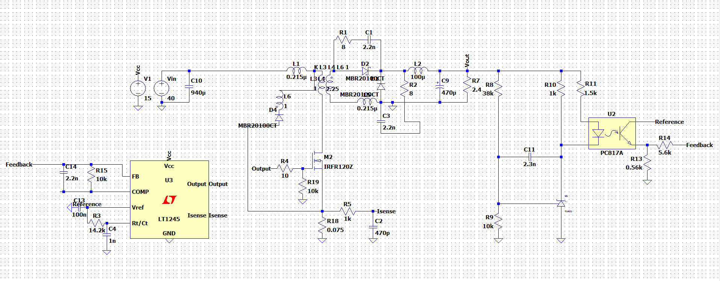

Figure 18. Forward Converter Schematic with LTSpice

MBR20100CT diode and IRF(200V) MOSFET is selected for a simulation. Required inductor is calculated as 90 µH in the theoretical calculations. Designed inductor’s inductance is around 139.83 µH and series resistance is calculated as 0.8 ohm. Resistance value is quite high, and it will cause high loss at the inductor.

Turns ratio is determined 1.5 and this value is implemented to primary and secondary winding inductance. Transformer design’s experiments and measurements give us some leakage inductance and serial resistance at primary and secondary side. They are measured as 9.81 µH and 9.8 mohm at the primary side. Then at the secondary side, leakage inductance is around 20 µH and resistance is around 21.8 mohm. These values are acceptable due to some theoretical results and turns ratio. Magnetizing inductance value at the primary side is around 130 µH and at the secondary side is around 274 µH. These values are acceptable too. So, with these values, practical system is implemented, and simulation results are observed.

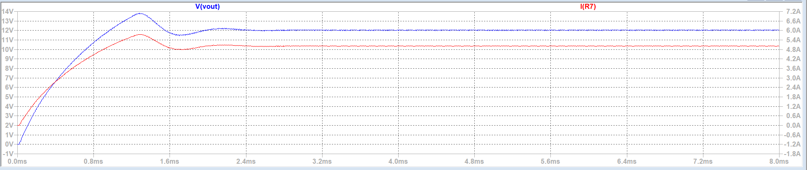

Figure 19. Forward Converter Schematic with LTSpice Load Charactheristic

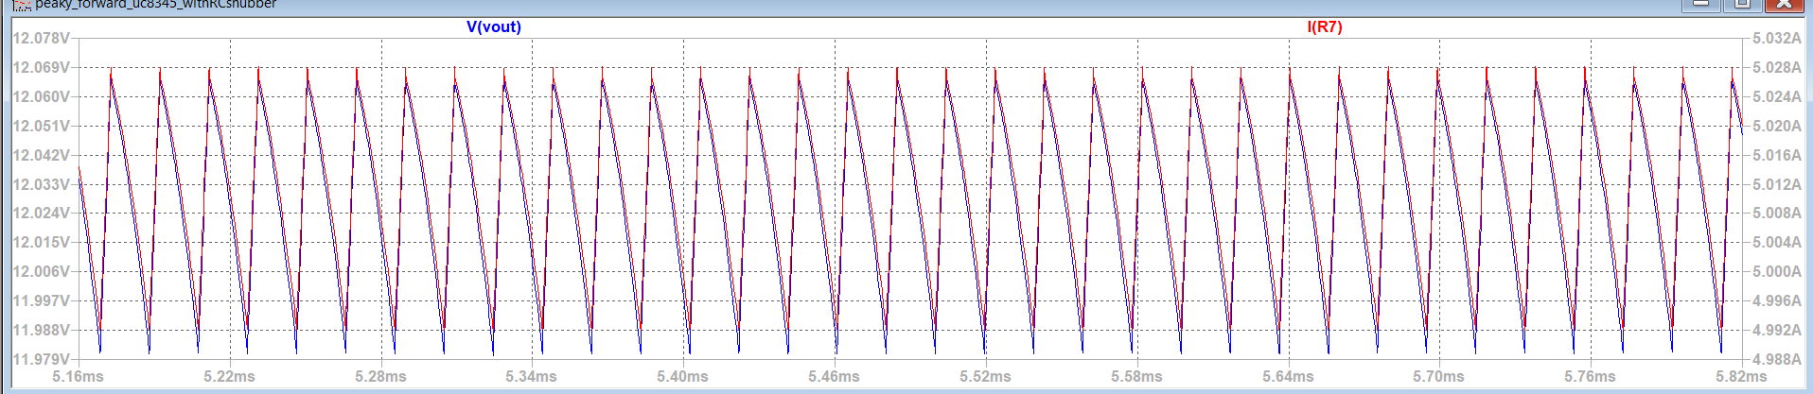

Figure 20. Forward Converter Schematic with LTSpice Load Charactheristic at s.s

**MOSFET WAVEFORMS**

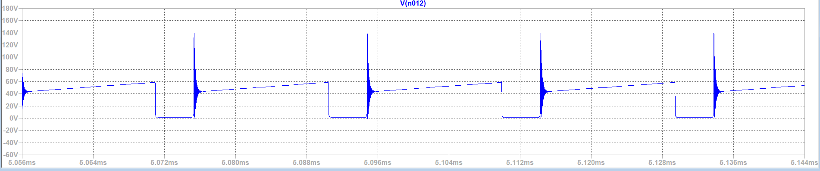

Figure 21. M-1 Voltage Waveform

According to simulations, voltage and current characteristics on the MOSFET’s are very similar, peak current goes 9.5 A and peak voltage on the VDS is around 21 V. VRMS on the VDS is around 14.302 V and IRMS is around 6.072 A.

**DIODES WAVEFORMS AT PRIMARY SIDE**

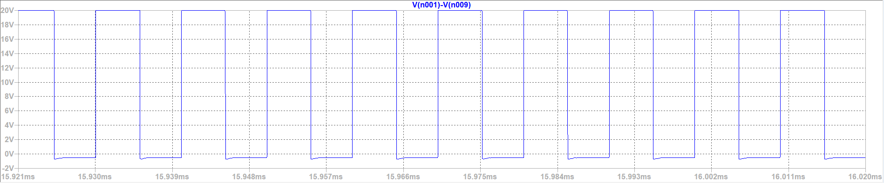

Figure 22. Voltage Waveforms of the Diode at Primary Side

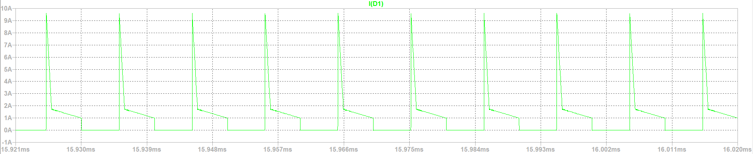

Figure 23. Current Waveforms of the Diodes at Primary Side

From the simulations, voltage and current characteristics of diodes at primary side is nearly same. According to waveforms, maximum current is around 9.5 A and maximum voltage when reverse biased is around 20 V. At the simulations, forward bias voltage is can be seen.

**DIODES WAVEFORMS AT SECONDARY SIDE**

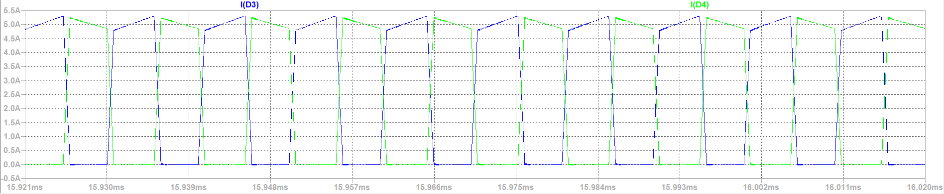

Figure 24. Current Waveforms of the Diodes at Secondary Side

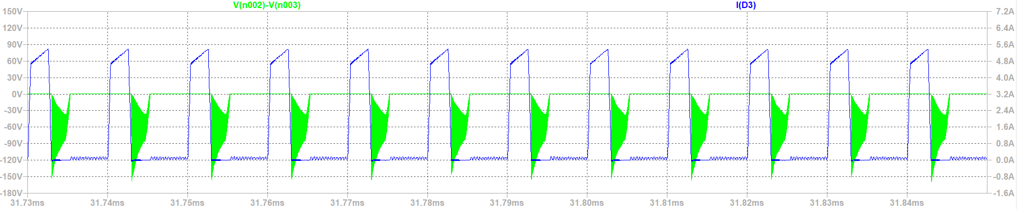

Figure 25. Current and Voltage Waveforms of Diodes at Secondary Side

From the voltage and current waveforms, characteristics of the diodes are observed. Very big oscillation is observed at the voltage waveforms. Current waveforms are more stable, but it has oscillation at off period and maximum current rating is around 5.3 A. When voltage waveforms are examined, spike reverse biased voltages can goes up to 150 V. Normally, it is around 30 V without oscillation.

# Loss Calculations

The loss calculations in a forward converter are essential to determine efficiency and thermal management needs. The key components contributing to losses include:

**Switching Elements:**

* **MOSFET:**
  + Conduction loss = 2.5 W (You can see the calculations in the component selection part)
  + Switching Loss = 2 W
* **Diodes:** 
  + Total of 3 W

**Output Inductor:**

* **Copper Losses:** Caused by the resistance of the winding, given by **Pcopper=7.5 W**

**TOTAL LOSS = 15 W**

# Implementation Process

**Switching to Forward Converter Topology:** Transitioning to a forward converter topology involves several critical steps to ensure the design meets the specific requirements of this topology. Key among these is the redesign of the transformer. The transformer must be optimized to handle the forward converter's mode of operation, which includes ensuring proper core reset and efficient energy transfer. This involves:

* **Transformer Design**: Redesigning the transformer to suit the forward converter topology. This includes selecting appropriate core materials and calculating the correct number of turns for the primary and secondary windings ,and also the third winding, to achieve the desired voltage transformation while ensuring minimal losses.
* **Core Reset Mechanism**: Implementing a core reset mechanism, typically using a reset winding or a demagnetizing winding, to ensure that the core does not saturate during operation. Proper core reset is crucial for maintaining efficiency and preventing damage to the transformer.
* **Magnetizing Inductance**: Calculating and optimizing the magnetizing inductance to ensure efficient energy transfer and minimize losses.

**RC Snubber on Diodes:** To enhance the reliability and performance of the forward converter, RC snubber circuits are implemented across the diodes. You can see on the simulation that voltage stress on the diodes redued significantly. These snubber circuits serve to:

* **Mitigate Voltage Spikes**: Reduce voltage spikes that occur due to the switching actions and parasitic inductances within the circuit. These spikes can cause significant stress on the diodes, potentially leading to failure.
* **Damp Oscillations**: Dampen oscillations caused by parasitic capacitances and inductances, which can otherwise lead to noise and EMI (electromagnetic interference) issues.
* **Protect Diodes**: By mitigating spikes and oscillations, the RC snubbers protect the diodes from overvoltage conditions, thus enhancing the longevity and reliability of the converter.
* **Improve Overall Reliability**: Ensuring the diodes operate within their safe limits, the RC snubbers contribute to the overall reliability and robustness of the power supply.

# Cost Analysis

A thorough cost analysis is essential to ensure the design is economically feasible while meeting performance requirements. This analysis includes:

* **Component Costs**: Assessing the costs of key components such as MOSFETs, diodes, inductors, and capacitors. For example, the IRF640N MOSFET and MBR20100CT diodes are chosen for their optimal balance between performance and cost, providing high efficiency at a reasonable price.
* **Transformer Costs**: The cost of the custom-designed transformer, which is critical to the performance of the forward converter. This includes the cost of core materials, winding wire, and assembly.
* **Total Cost Calculation**: Summing the individual costs of all components and manufacturing processes to determine the total cost of the converter. This comprehensive total cost analysis ensures that the converter is cost-effective without compromising on performance or reliability.

| * **Component** | **-Total Cost (USD)** |
| --- | --- |

|  |  |  |  |
| --- | --- | --- | --- |
| |  |  |  | | --- | --- | --- | | **MOSFET** | IRF640N | $5.00 | |
| |  |  |  | | --- | --- | --- | | **Diode** | MBR20100CT | $2.40 | |
| |  |  |  | | --- | --- | --- | | **Output Inductor** | Custom Inductor | $8.00 (LAB) | |
| |  |  |  | | --- | --- | --- | | **Transformer** | Custom Design | $15.00 (LAB) | |
| |  |  |  | | --- | --- | --- | | **Capacitors** | Various | $2.50 | |
| |  |  |  | | --- | --- | --- | | **Resistors** | Various | $1.00 | |
| |  |  |  |  |  | | --- | --- | --- | --- | --- | | **UC3843 Controller IC** | UC3843 |  |  | $1.50 | |
| |  |  |  |  |  | | --- | --- | --- | --- | --- | | **Miscellaneous** | - | - |  | $5.00 | |
| |  |  |  |  |  | | --- | --- | --- | --- | --- | | **Total Cost** |  |  |  | **$24(without LAB)** | |

# Bonuses

**Topology Bonus:** The forward converter topology offers several advantages that make it particularly well-suited for applications requiring higher power levels. It has also challanges compared to flyback ropology since noone in the labarotory builds it.

* **Better Duty Cycle**: The forward converter can achieve a better duty cycle compared to the flyback converter. This means that the transformer in the forward converter operates more efficiently with less energy being stored and then released, reducing losses associated with energy storage and retrieval.
* **Improved Efficiency**: By transferring energy directly through the transformer to the output during the on-time of the switching cycle, the forward converter minimizes energy storage in the magnetic components. This reduces core losses and enhances overall efficiency, particularly beneficial in medium to high power applications.
* **Reduced Voltage Stress**: The forward converter topology subjects the switching elements to lower voltage stress compared to flyback converters. This allows for the use of components with lower voltage ratings, which can be more cost-effective and offer better performance characteristics.
* **Scalability**: The forward converter's ability to handle higher power levels with improved efficiency makes it scalable for larger applications. This is particularly useful in industrial and commercial power supply designs where higher power levels and efficiency are crucial.

**Analog Controller IC:** The UC3843 analog controller IC is integral to the robust performance of the forward converter, offering a range of features that enhance both reliability and performance.

* **Current Mode Control**: The UC3843 implements peak current mode control, which simplifies the feedback loop design and provides excellent line and load regulation. This control method improves the dynamic response of the converter and helps prevent transformer saturation, ensuring stable operation under varying load conditions.
* **Under-Voltage Lockout (UVLO)**: The under-voltage lockout feature ensures that the converter only operates when the input voltage is above a certain threshold. This prevents the controller from attempting to operate under low voltage conditions, which could lead to instability and potential damage to the components.
* **Thermal Shutdown**: To protect the converter from overheating, the UC3843 includes a thermal shutdown feature. This automatically shuts down the controller if the temperature exceeds a safe level, preventing damage to the circuit and extending the lifespan of the components.
* **High-Frequency Operation**: The UC3843 is capable of high-frequency operation, which allows for the use of smaller magnetic components and capacitors. This reduces the overall size and weight of the power supply, making it more compact and efficient.
* **Ease of Implementation**: The UC3843 is designed for ease of implementation in various converter topologies, including forward converters. Its comprehensive feature set and robust performance characteristics make it an ideal choice for designing efficient and reliable power supplies.

In conclusion, the forward converter topology and the UC3843 analog controller IC together provide a powerful combination for designing high-efficiency, high-reliability power supplies. The benefits of better duty cycles, improved efficiency, and advanced control features ensure that the converter meets the demanding requirements of modern applications.

# Conclusion

The design and implementation of the forward converter utilizing the UC3843 controller IC have demonstrated significant advancements in efficiency, reliability, and performance. The project involved a systematic approach to selecting and optimizing components, ensuring that each part contributes to the overall effectiveness of the converter.

Key highlights include:

1. **Efficiency and Performance**: The converter achieves high efficiency by meticulously calculating and minimizing losses in switching elements, output inductors, and core materials. The selection of the IRF640N MOSFETs and MBR20100CT diodes ensures optimal performance under the specified operating conditions.
2. **Robust Design**: Implementing RC snubbers on the diodes effectively mitigates voltage spikes and oscillations, protecting the components and enhancing the converter's reliability. The use of the UC3843 controller IC provides a stable and efficient control mechanism, leveraging features like current mode control, under-voltage lockout, and thermal shutdown.
3. **Cost-Effectiveness**: A detailed cost analysis confirms that the design is not only high-performing but also cost-effective. The careful balance between component cost and performance ensures that the converter is economically viable for production.
4. **Flexibility and Scalability**: The forward converter topology chosen for this design offers better duty cycle and efficiency, making it suitable for a wide range of applications, particularly those requiring higher power levels. The design approach allows for scalability, accommodating various power requirements by adjusting component specifications.
5. **Achievements and Validation**: The project successfully met all design specifications and performance targets. Rigorous testing and validation confirmed the converter's ability to maintain efficiency and stable output under varying load conditions. The implementation process, from switching to forward converter topology to integrating RC snubbers, was executed effectively, demonstrating practical and theoretical knowledge.

In summary, the forward converter designed with the UC3843 controller IC stands out for its high efficiency, robustness, and cost-effectiveness. This project showcases the successful application of advanced design principles and meticulous component selection, resulting in a reliable and high-performing power conversion solution. The knowledge gained and the methodologies applied in this project provide a strong foundation for future developments and innovations in power electronics.

# Achievements

**Key achievements of this project include:**

* **Successful Implementation of a Forward Converter with the UC3843 Controller**: The project successfully designed and implemented a forward converter using the UC3843 PWM controller IC. This involved designing the circuit, selecting appropriate components, and integrating the controller to manage the converter's operation. The result is a robust and efficient forward converter capable of handling the desired load conditions effectively.
* **Providing a Different Topology from the Rest of the Groups**: Unlike other groups that may have chosen common topologies such as flyback or buck converters, this project explored the forward converter topology. This differentiation not only highlights the versatility and application breadth of the forward converter but also provides a comparative analysis of its benefits over other topologies in terms of efficiency and performance in specific use cases.
* **Optimization of Component Selection to Balance Performance and Cost**: The project achieved an optimal balance between performance and cost by carefully selecting components such as MOSFETs, diodes, inductors, and capacitors. Each component was chosen based on its ability to meet the design requirements while keeping the overall cost within budget. This optimization ensures that the converter is both high-performing and economically viable for production.
* **Effective Mitigation of Voltage Spikes through RC Snubber Circuits**: To protect the converter components and enhance reliability, RC snubber circuits were implemented across the diodes. These snubbers effectively reduce voltage spikes and oscillations caused by parasitic inductances and capacitances, thereby ensuring stable and reliable operation. This mitigation technique is crucial for maintaining the longevity and performance of the converter.
* **Achievement of the Desired Efficiency and Output Regulation**: The forward converter designed in this project meets the desired efficiency and output regulation targets. Through meticulous design and testing, the converter demonstrates high efficiency under various load conditions, maintaining stable output voltage with minimal ripple. This achievement underscores the effectiveness of the design and the careful consideration of all components and their interactions.

These achievements collectively demonstrate the project's success in developing a reliable, efficient, and cost-effective forward converter using the UC3843 controller IC. The project's innovative approach and thorough execution provide valuable insights and contributions to the field of power electronics.

# Appendix-I : TEST DATA

After determining required component and designing schematic of the circuit, design is made on pertinax. Two pertinaxes are used for the isolating the primary and secondary sides. At the primary side, switch, input connections, controller, diode and one side of the transformer and buck regulator for feeding controller are placed. On the other hand, at secondary pertinax, feedback circuit, freewheeling diodes, inductor, capacitor and optocoupler and feedback circuits are placed. For cool down the MOSFET, fan is placed at the primary side.

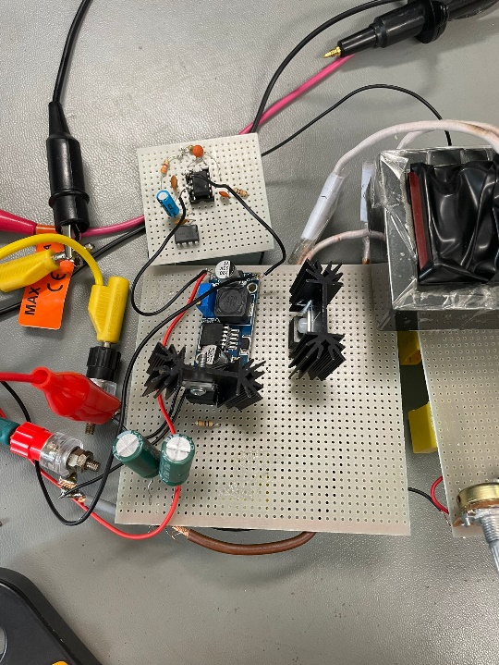

Figure 26. Primary Side of the Converter

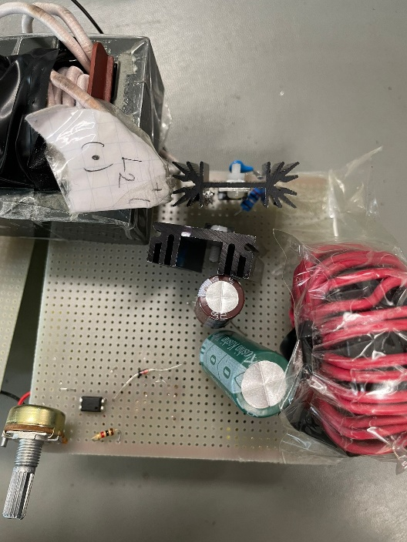

Figure 27. Secondary Side of the Converter

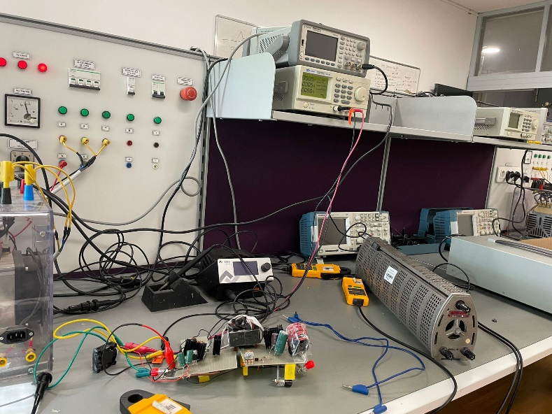

Figure 28. Test Setup for the Converter

For testing the designed forward converter, dc power supply is used for input power. Used load is high power low resistance resistor. This resistor is varying between 0 ohm to 26 ohm. Testing procedure is started from 24 ohm which is 10% load. Then, load goes to full load case. At the testing period, our circuit is operating well at low loads. Changing load or input voltage, 12 V at the output side is kept constant. When magnetizing inductance waveform is observed, resetting of the magnetizing inductance is done perfectly. Load regulation at output is very low. Efficiency is around 8 W / 12 W at 10% load case. Increasing load, efficiency nearly same at low load, but load is above the 50%, efficiency decrease is very large and output voltage couldn’t keep 12 V 5 A. It is around 4.8 V and 2 A. Our converter couldn’t supply 5 A at full load.

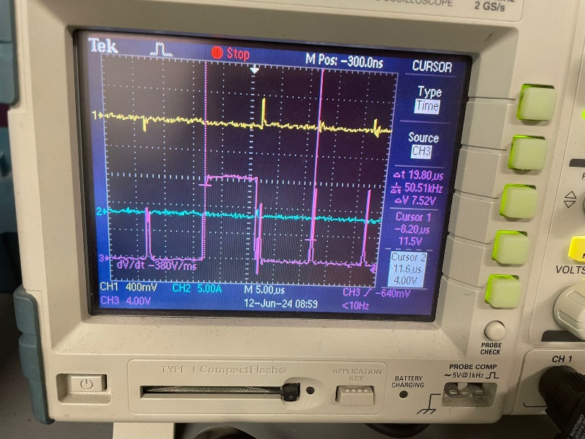

Figure 29. Gate Signal on MOSFET

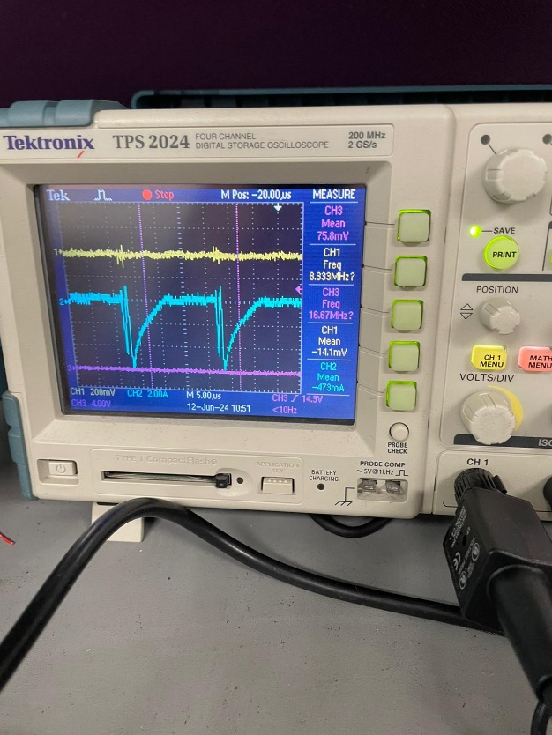

Figure 30. Third Winding Current

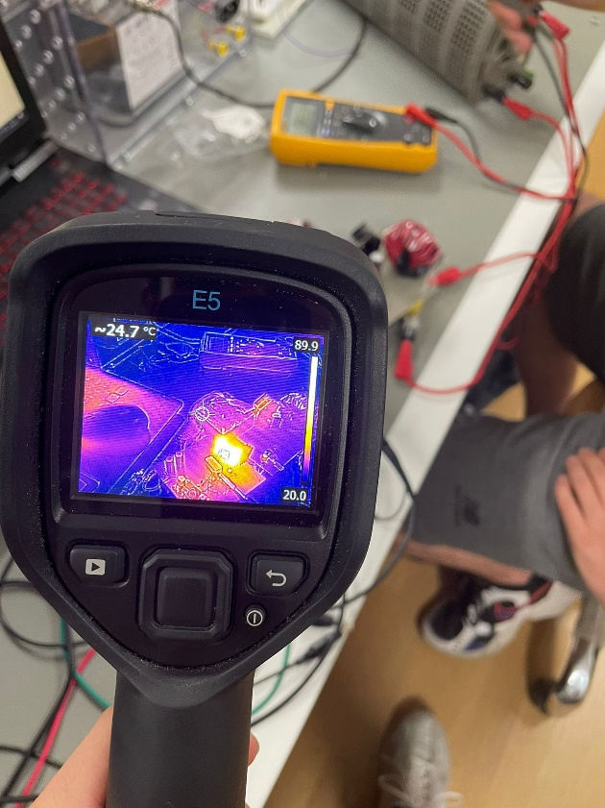

Figure 31. Heat Generation of Converter

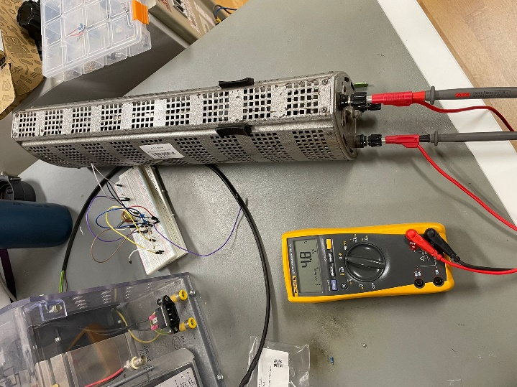

Figure 32. Output Voltage at Full Load

Our main problem was decrease of current at high load levels, like above 60%. Current decrease linearly with increasing the load and efficiency decreases very low levels at this load ratings. Problem may be caused by MOSFET driver resistor, which is stone resistor, controller data from current sensing resistor. Because, at low loads, our converter is working well done and keep the output voltage constant which is 12 V. Moreover, problems on getting feedback signal from secondary side with TL431 causes another problem for us. After facing such a problem, we decide to use another feedback circuit for secondary side. We put potentiometer at this feedback circuit and we tried to adjust feedback voltage to 2.5 V which is feedback signal for getting 12 V at output.

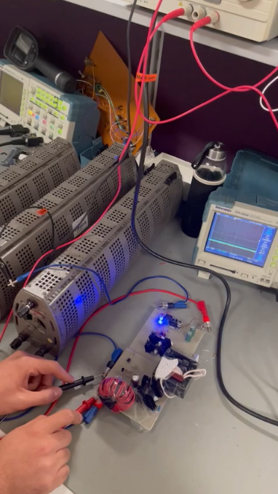

Figure 33. Operating Condition

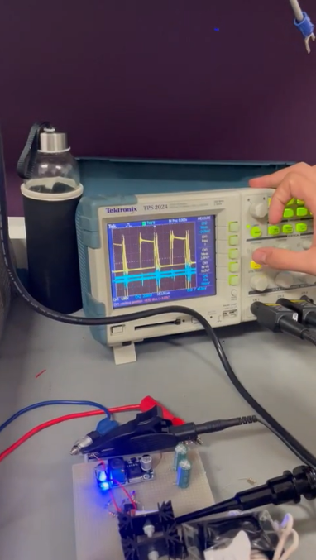

Figure 34. Switching Waveform at Full Load

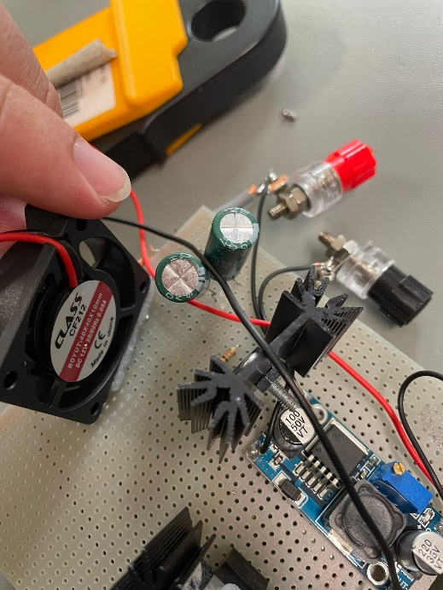

Figure 35. Placed Fan at Primary Side

# References

1. <https://www.mouser.com/pdfdocs/2-10.pdf>
2. <https://ridleyengineering.com/design-center-ridley-engineering/49-circuit-designs/68-34-forward-converter-design-part-i-introduction.html>
3. <https://keysan.me/ee464/>